DSP Playground

0.2.2 Release Notes

This version corrects the error described in the last version’s release notes.

In order to do that, the sampling rate must be increased so the spike pairs frequency aren’t audible for humans. Considering a sampling rate of 20kHz and the spectrum equation k(smplRate) ± 440Hz, the first undesired signal would occur at 19560Hz, which is close enough to not human audible. Therefore it would be useless to increase the sampling rate even more than ~20kHz, only making it more inefficient and harder to design the filter (wider transition band; increased need for coefficient precision).
This done and the filter redesigned to 20kHz sampling rate:

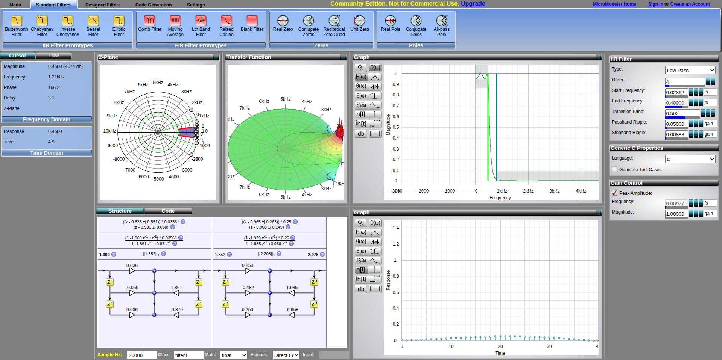

The expected result has been achieved. The sawtooth wave is artificially generated (~112.6kHz sample rate). When you hear its DAC channel through the speaker, you notice the timbre. The ADC reads the sawtooth at 20kHz, and inputs the data to the DSP digital filter. Its output is channeled through PA5 (DAC). When the speaker is connected to this channel, it produces a sound roughly identical to the one by a diapason (perfect sine wave).
The digital filter successfully extracted only the fundamental frequency from a compound wave funciton.

I need an oscilloscope to verify the amplitude, offset, frequency and harmonics of the output signal to check if they’re really as they should, but I don’t have access to any at the moment. However, by comparing the speaker output sound to the diapason and checking the frequency with a tuner app (image below), it is possible to conclude that a behavior close to the desired would be observed.

